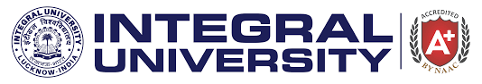

**WORLD SCIENCE DAY 2023**

**“Building Trust in Science”**

**Organized by**

**Department of Chemistry**

**Date: 10th November, 2023, Venue: D113**

Celebrated every 10 November, World Science Day for Peace and Development highlights the important role of science in society and the need to engage the wider public in debates on emerging scientific issues. It also underlines the importance and relevance of science in our daily lives. By linking science more closely with society, World Science Day for Peace and Development aims to ensure that citizens are kept informed of developments in science. It also underscores the role scientists play in broadening our understanding of the remarkable, fragile planet we call home and in making our societies more sustainable. To commemorate this event, the Department of Chemistry, Integral University organized multi-events including Poster Making, Slogan Writing, Oral Presentation, and a Quiz Competition, centred around the theme of the event “Building Trust in Science”. The event was also aligned with the **Sustainable Development Goals (SDGs) Quality Education (SDG 4) and Responsible Consumption and Production (SDG 12)**. The plethora of events provided a wonderful opportunity for the students to showcase their talent and scientific knowledge. The competition was judged by Prof. Malik Nasibullah from the Department of Chemistry, Dr. Swati Sharma from the Department of Biosciences and Dr. Najmuddin Ahmad from the Department of Mathematics and Statistics. The judges lauded the efforts made by the participants. The event was coordinated by **Dr. Naseem Ahmad**, **Dr. Tahmeena Khan** and **Dr. Mohd. Imran Ahmad** from the Department of Chemistry. The faculty coordinators were ably supported by Mohd Arsh Khan (B.Sc. IC 3rd Year) and Wazeeha Zubair Ansari (B.Sc. ZBC 3rd Year) who volunteered as student coordinators. About 60 students from different academic streams participated enthusiastically and the winners were felicitated by medals and certificates. The winners of each event are mentioned below:

* **Poster Making:**

Ist Position- Fiza Khan (B.Sc. ZBC IIIrd Year)

IInd Position- Sidra Fatima (B.Sc. IC Ist Year)

IIIrd Position- Aqsa Malik (B.Sc. ZBC IIIrd Year)

* **Slogan Writing:**

Ist Position- Pushpanjali Maurya (B.Sc. ZBC 3rd Year)

IInd Position- Shweta Singh (B.Sc. ZBC 3rd Year)

IIIrd Position- Mantasha Zafar (B.Sc. ZBC 3rd Year)

* **Oral Presentation:**

Ist Position- Fiza Khan (B.Sc. ZBC 3rd Year)

IInd Position- Khushi Ali (B.Sc. ZBC 3rd Year)

IIIrd Position- Mantasha Zafar (B.Sc. ZBC 3rd Year)

* **Quiz:**

Ist Position- Wazeeha Zubair Ansari (B.Sc. ZBC 3rd Year)

IInd Position- Mohd Arsh Khan (B.Sc. IC 3rd Year)

IIIrd Position- Mantasha Zafar (B.Sc. ZBC 3rd Year)

The event not only celebrated the significance of World Science Day but also served as a platform to promote scientific awareness and instil a sense of responsibility in the scientific community and contributed to the global effort of fostering trust and confidence in scientific endeavour.

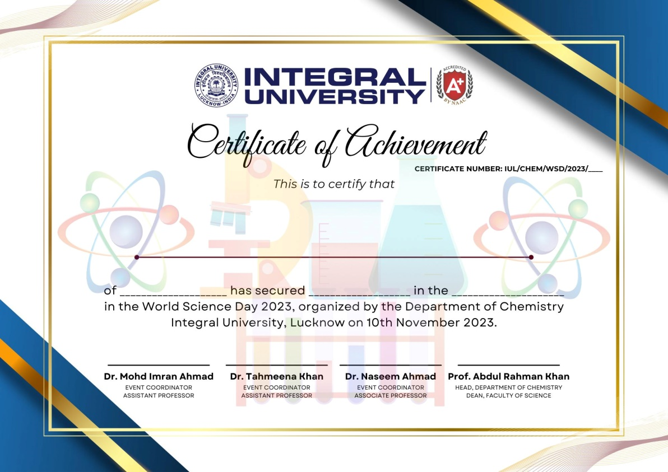

**SAMPLE CERTIFICATE**

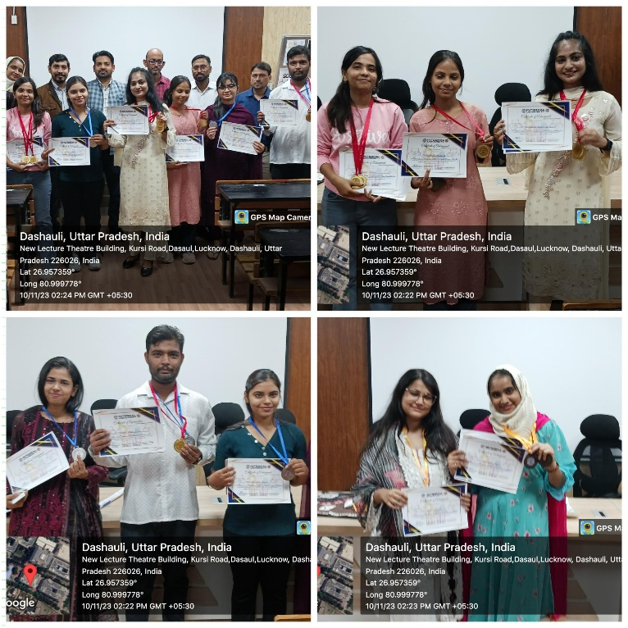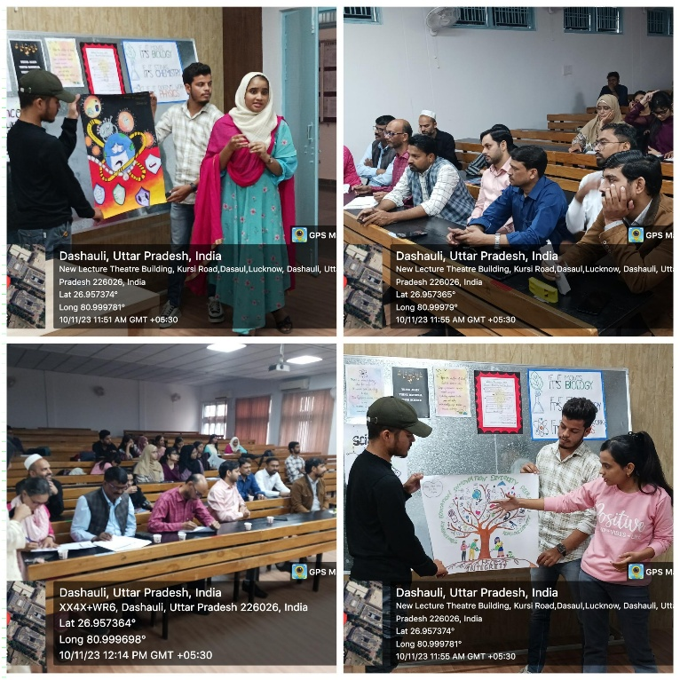**GLIMPSES OF THE EVENT**

**Submitted by:**

**Dr. Tahmeena Khan**